
SECP3623
Database Programming
2025/2026 SEMESTER 1
Assignment 1 (10%)

Name | : | WOO CHENG SHUAN
Matric Id | : | A23CS0283
Section | : | 02

Task 1: DATABASE CREATION AND INTEGRITY CONSTRAINTS
SQL COMMAND | OUTPUT / RESULT
- CREATE DATABASE
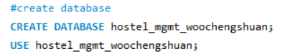  Use CREATE DATABASE to create a new database. | 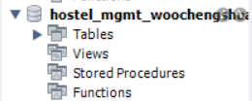
- CREATE TABLES
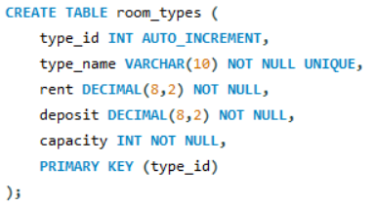  Use CREATE TABLE to create table ‘room_types’ with the entities. Add constraints such as PRIMARY KEY, NOT NULL AND UNIQUE. | 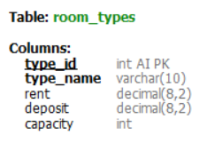
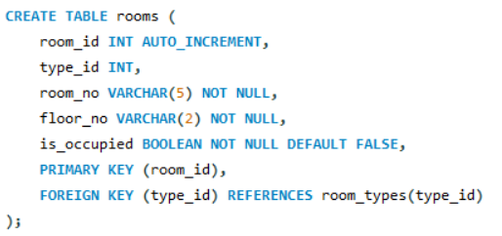  Use CREATE TABLE to create table ‘room’ with the entities. Add constraints such as PRIMARY KEY, FOREIGN KEY and NOT NULL. | 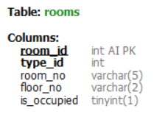
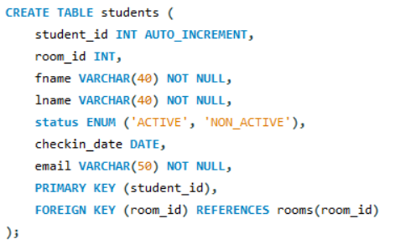  Use CREATE TABLE to create table ‘students’ with the entities. Add constraints such as PRIMARY KEY, FOREIGN KEY and NOT NULL. | 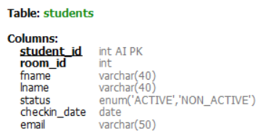
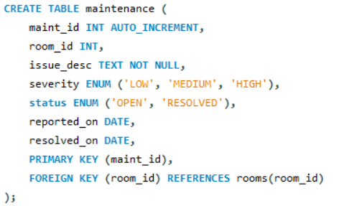  Use CREATE TABLE to create table ‘maintenance’ with the entities. Add constraints such as PRIMARY KEY, FOREIGN KEY and NOT NULL. | 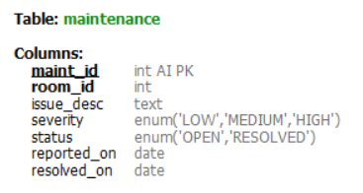
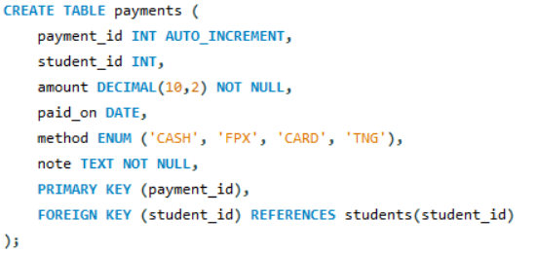  Use CREATE TABLE to create table ‘payments’ with the entities. Add constraints such as PRIMARY KEY, FOREIGN KEY and NOT NULL. | 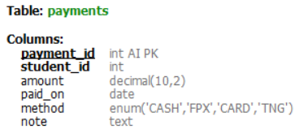
- ALTER TABLE: add an email column to students and mark it UNIQUE
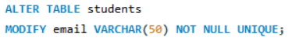  Use ALTER TABLE to MODIFY email columns into UNIQUE. | 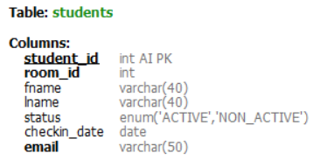
- DROP TABLE: create a temporary test table and drop it safely
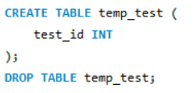 | 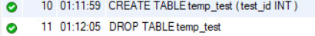

TASK 2: DATA MANIPULATION AND FILTERING
SQL COMMAND | OUTPUT / RESULT
- DATA INSERTION (DML)
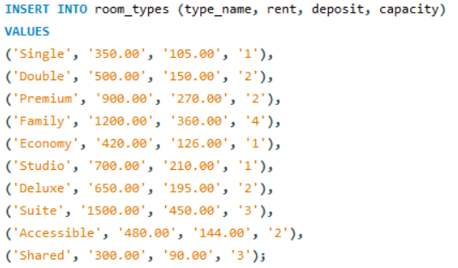  Use INSERT INTO … VALUES to insert 10 valid records into the table ‘room_types’ while the ‘type_id’ column data is created by auto increment. Ensuring that there is a containing value between 400 and 800. | 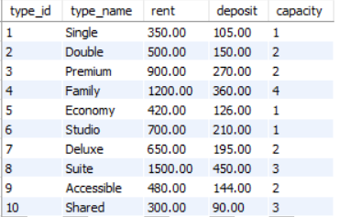
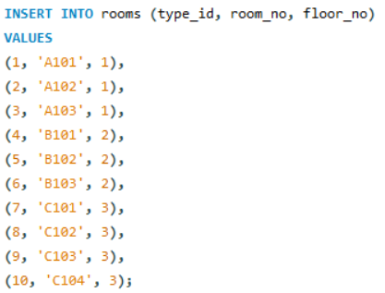  Use INSERT INTO … VALUES to insert 10 valid records into the table ‘rooms’ while the ‘room_id’ column data is created by auto increment and the ‘is_occupied’ is created by a default value of FALSE (0).  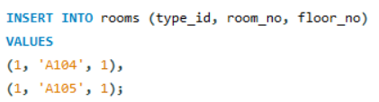  Data is added for the second time since I noticed there is no output value for the fourth question of the summary queries part. | 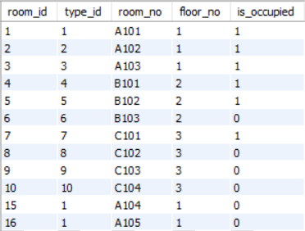
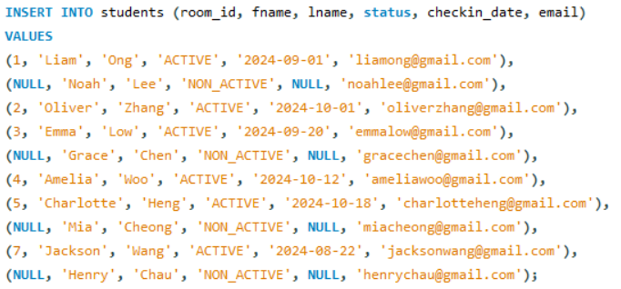  Use INSERT INTO … VALUES to insert 10 valid records into the table ‘students’ while the ‘student_id’ column data is created by auto increment. Ensuring that there is at least one student’s name starts with the letter ‘A’.  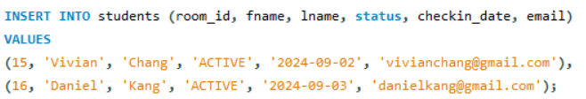  Data is added for the second time since I noticed there is no output value for the fourth question of the summary queries part. | 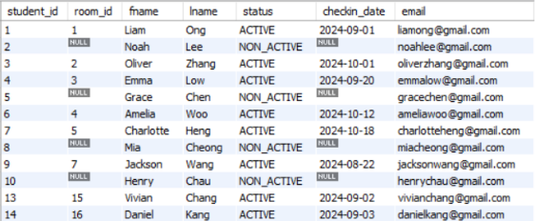
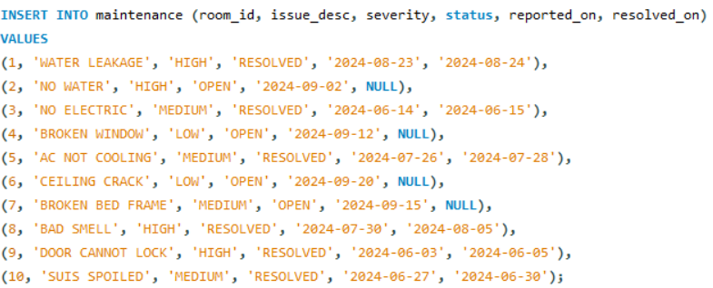  Use INSERT INTO … VALUES to insert 10 valid records into the table ‘maintenance’ while the ‘maint_id’ column data is created by auto increment, including three severity types and two statuses in the table.  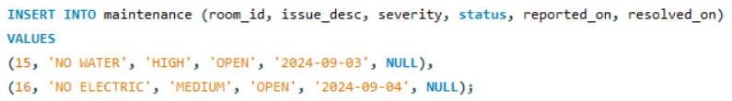  Data is added for the second time since I noticed there is no output value for the fourth question of the summary queries part. | 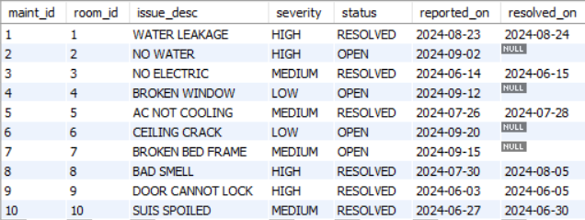  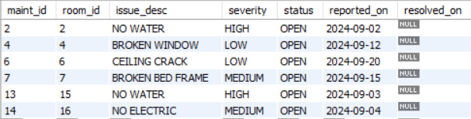
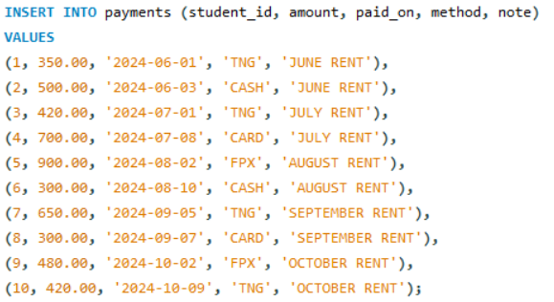  Use INSERT INTO … VALUES to insert 10 valid records into the table ‘payments’ while the ‘payment_id’ column data is created by auto increment, including four payment methods in the table. | 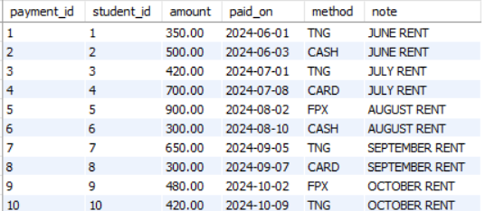
- UPDATE AND DELETE OPERATIONS
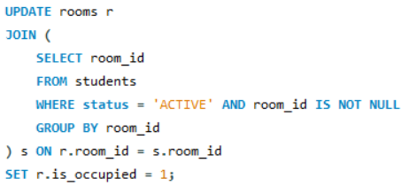  Update the column ‘is_occupied’ to (1) from the table of ‘room’ when it finds out that there is at least one student ‘ACTIVE’ in the same ‘room_id’ from the table of ‘students’ and ‘rooms’. | 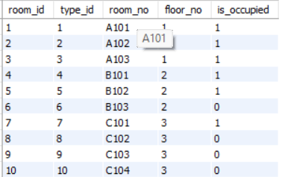
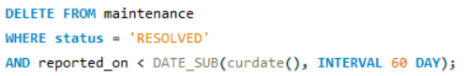  Delete the row in the table ‘maintenance’ when the status shows ‘RESOLVED’ and has already passed 60 days. | 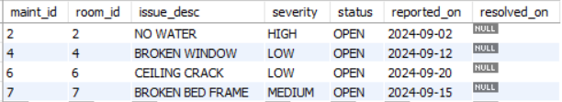
- DATA RETRIEVAL AND FILTERING QUERIES
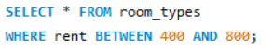  Display the row from the table ‘room_types’ where the rent value is between RM400 and RM800. | 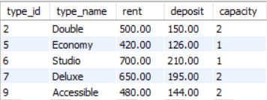
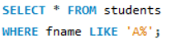

Display the row from the table ‘students’ where the first name of the student starts with the letter ‘A’.

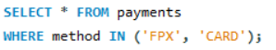  Display the row from the table ‘payments’ where the students pay using ‘FPX’ or ‘CARD’. | 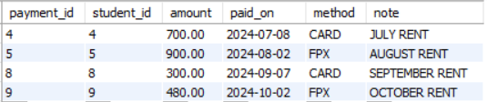
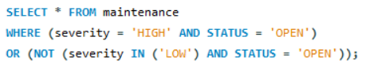  Display the row from the table ‘maintenance’ where the severity is high and medium, and status with ‘OPEN’. | 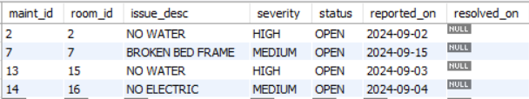
- FUNCTION AND EXPRESSIONS
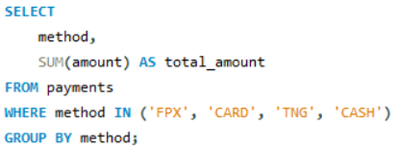  Calculate the sum of the amount with the category of payment method and display it in a table. | 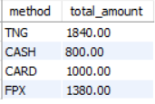
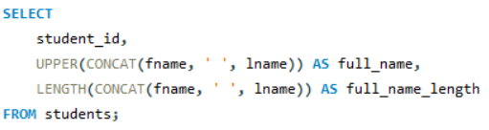  Display the combined first name and last name as ‘full_name’ and mention the total length of the first name and last name in a table. | 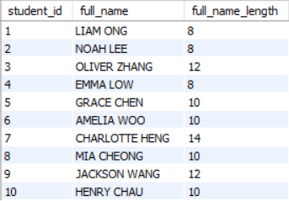

TASK 3: REPORTING AND AGGREGATION
SQL COMMAND | OUTPUT / RESULT
- CREATE A VIEW v_room_status WITH COLUMNS
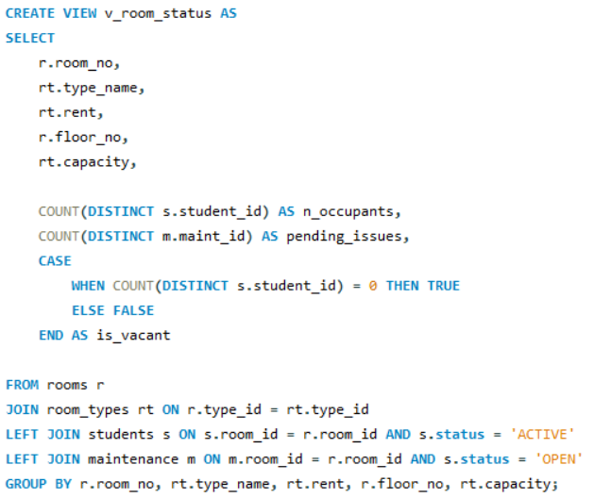  USE CREATE VIEW to create a virtual table named ‘v_room_status’.  Use SELECT the column of ‘room_no’, ‘type_name’, ‘floor_no’, ‘capacity’ directly from the original tables, which are ‘rooms’ stands for r, and ‘room_types’ stands for rt.  Use COUNT to count the number of students checked into the room and name as ‘n_occupants’. Also, count the number of pending maintenance tasks for the room and name it as ‘pending_issues’.  Use CASE WHEN to identify whether the room is vacant or not in a boolean state.  These lines JOIN each room with its room type, active students, and open maintenance issues, then GROUP the data so every room appears as one row with correct counts of occupants and issues. | 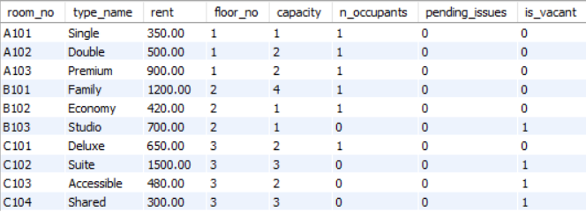
- SUMMARY QUERIES
- Total number of students per room type
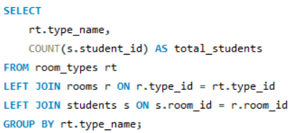  Use COUNT to calculate the total number of students for each room type. The query starts from ‘room_types’, LEFT JOIN it with ‘rooms’ and then ‘students’ to include all room types even if they have no rooms or students, and finally GROUP BY the room type. | 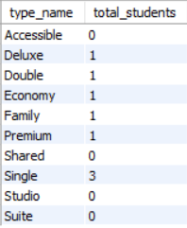
- Average rent and total deposit per room type
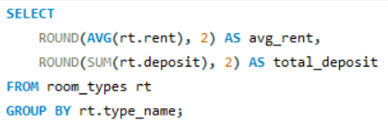  ROUND up the average rent to 2 decimal points and ROUND the SUM of the total deposit to 2 decimal points. GROUP them to make sure the calculation is done for each room type. | 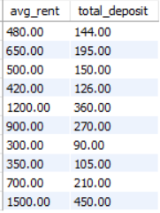
- Monthly payment totals grouped by year & month
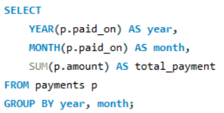  ‘YEAR(p.paid_on)’ and ‘MONTH(p.paid_on)’ extract from the table ‘payments’. SUM the payment amount into ‘total_payment’ column. GROUP BY year and month to see the unique values calculated. | 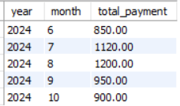
- Count of OPEN maintenance issues per floor using HAVING COUNT > 2
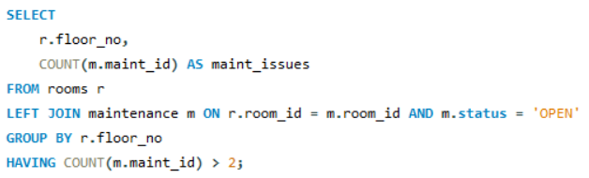  COUNT the number of open maintenance issues per floor. LEFT JOIN is used to connect the table of ‘maintenance’ and ‘room’ when ‘m.status’ = ‘OPEN’. | 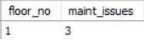
- APPLY SQL FUNCTIONS
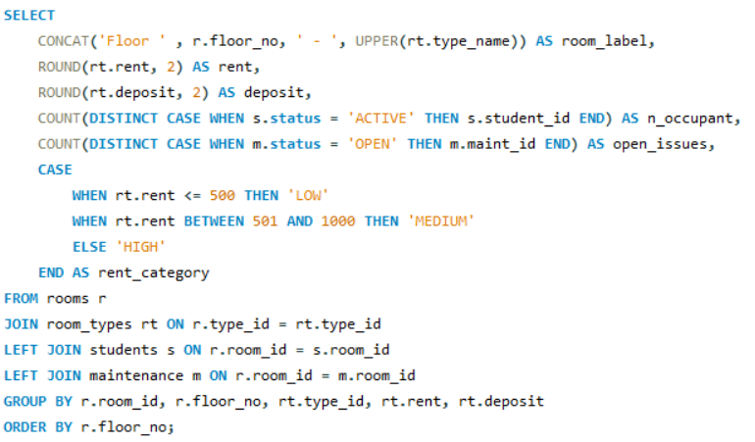  Generate a summary of each room, combining the ‘floor_no’, ‘type_name’, ROUND ‘rent’ value in 2 decimal points, ROUND ‘deposit’ value in 2 decimal points, COUNT the number of student in each room, COUNT the number of open maintenance issue in each room, and categorized the room class into three classes by the rent value of each room.  LEFT JOIN includes rooms with no students or issues, and GROUP BY to ensure accurate counts per room, while ORDER BY sorts by the floor number. | 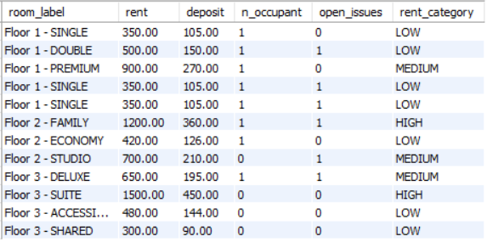

MARKING RUBRICS
Task | Criteria | Marks | Total Marks
Task 1  Database Creation & Constraints | Creation of database and all tables with valid keys, datatypes, and constraints (PK, FK, NOT NULL, UNIQUE). Logical order and referential integrity preserved. | 3
 | ALTER TABLE (add email UNIQUE) and DROP TABLE demonstration executed successfully and documented. | 2
 | Insertion order, valid FK references, and no orphan data. | 2
Task 2  Data Manipulation & Filtering | Five tables populated with ≥10 valid records each; varied and meaningful data UPDATE/DELETE executed correctly with logical results. | 1
 | Accurate use of WHERE, BETWEEN, LIKE, IN, AND/OR/NOT queries. | 3
 | Correct use of aggregate and string functions (COUNT, CONCAT, and more). | 2
Task 3  Reporting & Aggregation | VIEW creation | 2
 | Use of GROUP BY, HAVING, ROUND, and CASE with accurate aggregated results. | 3
 | Clear labelling, readable outputs, screenshots show executed results. | 2
Total (20)

